Investigar como funcionan las ramas de git
* {
margin: 0;
padding: 0;
box-sizing: border-box;
font-family: 'Gill Sans', 'Gill Sans MT', Calibri, 'Trebuchet MS', sans-serif;
}

"selector de contenedor" {
display: flex;
justify-content: center;
align-items: center;
min-height: 100vh;
}

PROPÍEDADES DE TRANSFORM: (transforma el elemento a nivel visual

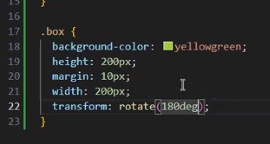
TRANSITIONS:
https://www.w3schools.com/css/css3_transitions.asp
https://developer.mozilla.org/en-US/docs/Web/CSS/Guides/Transitions/Using
http://web.dev/learn/css/transitions?hl=es-419
Transition + Transform:
https://www.w3schools.com/css/tryit.asp?filename=trycss3_transition_transform
TRANFORM :
https://www.w3schools.com/cssref/css3_pr_transform.php
https://developer.mozilla.org/en-US/docs/Web/CSS/Reference/Properties/transform
POSITION:
https://www.w3schools.com/css/css_positioning.asp
ANIMATION:
https://developer.mozilla.org/en-US/docs/Web/CSS/Reference/Properties/animation
Las web W3school y MDN tienen documentación y ejemplos.

